CST-239 Milestone-3 Inventory Manager and Shopping Cart
Nejla Yber
Grand Canyon University
CST-239 Programming in Java II
Kenia Madrazo
6/07/2026

Description
This project is a console-based Fantasy Game Store application developed in Java. Users can view products, purchase products, view the shopping cart, return products, and also exit the application. The store inventory includes weapons, armor, and health items. The application also demonstrates object-oriented programming concepts such as inheritance, encapsulation, composition, polymorphism, and interfaces.

UML Diagram Screenshot
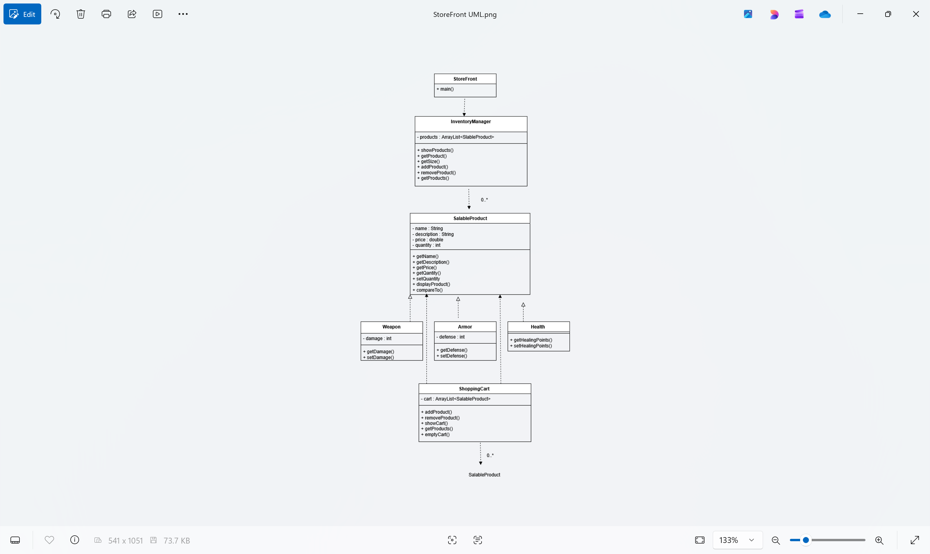

Flowchart Screenshot
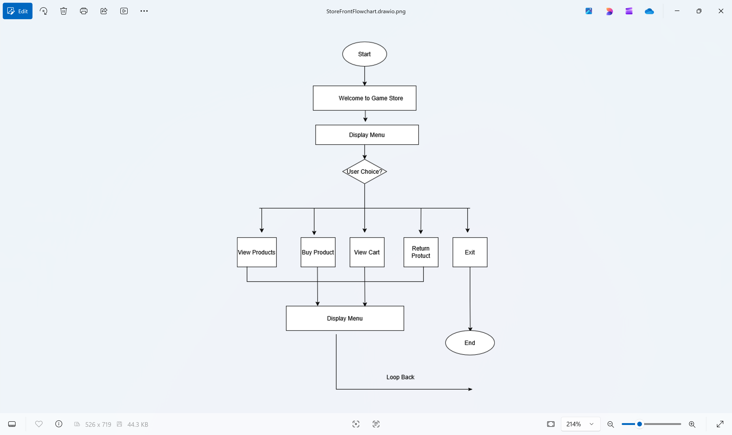

Theory of Operation
The Fantasy Game Store application is a Java menu-driven program that allows the user to interact with a virtual game store. When the application starts, the InventoryManager will fill the store inventory with a handful of products such as weapons, armor, and health items. A ShoppingCart object is also instantiated to contain the products picked by the user.
The StoreFront class has the main() function and presents a menu that lets the user view products, buy products, view the shopping basket, return products or exit the application. The user input is handled in a loop until the user wants to quit.
The InventoryManager class handles all the products offered in the store. It maintains products in an ArrayList of SalableProduct objects and has methods to show, add, remove and get products from the inventory.
The ShoppingCart class is responsible for the products the user selects. At time of purchase can be added to the cart and when returned can be taken away. You can always look at the items of your shopping cart.
The SalableProduct class is the base class for all products in the store. The Weapon, Armor and Health classes inherit from SalableProduct and add their own specialized properties. This shows inheritance and reuse of code.
The application also exhibits polymorphism, since Weapon, Armor and Health objects are saved and retrieved via SalableProduct references. Both InventoryManager and ShoppingCart classes have collections of SalableProduct objects. This is composition.
The SalableProduct class implements Comparable. Products are compared alphabetically by name, case insensitive, then by price if product names are the same.
The software also continues to operate until the user chooses the Exit option from the menu.

Program Output Screenshots
Screenshot1 - Product Inventory Display
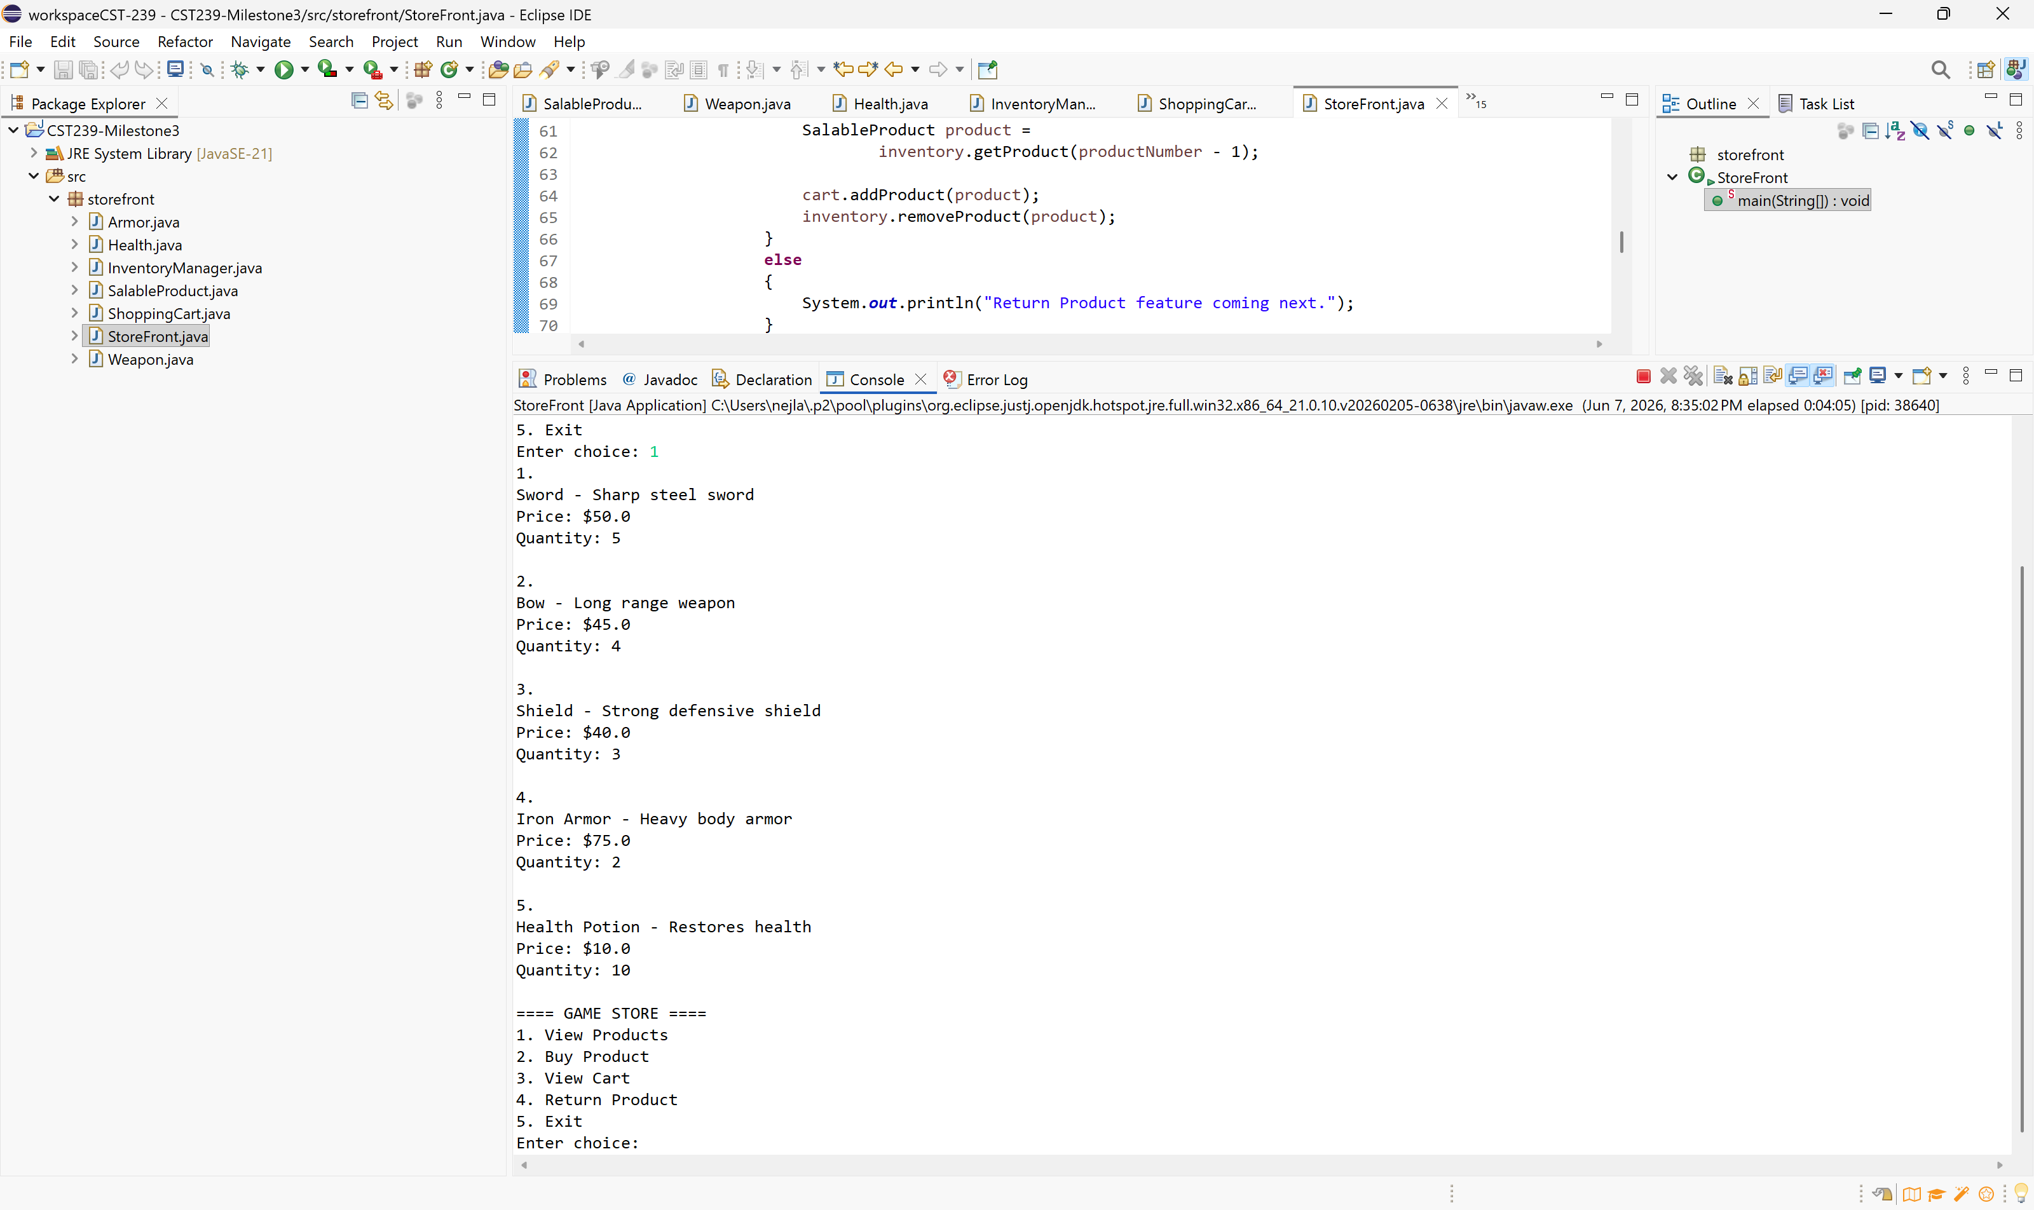

Screenshot2
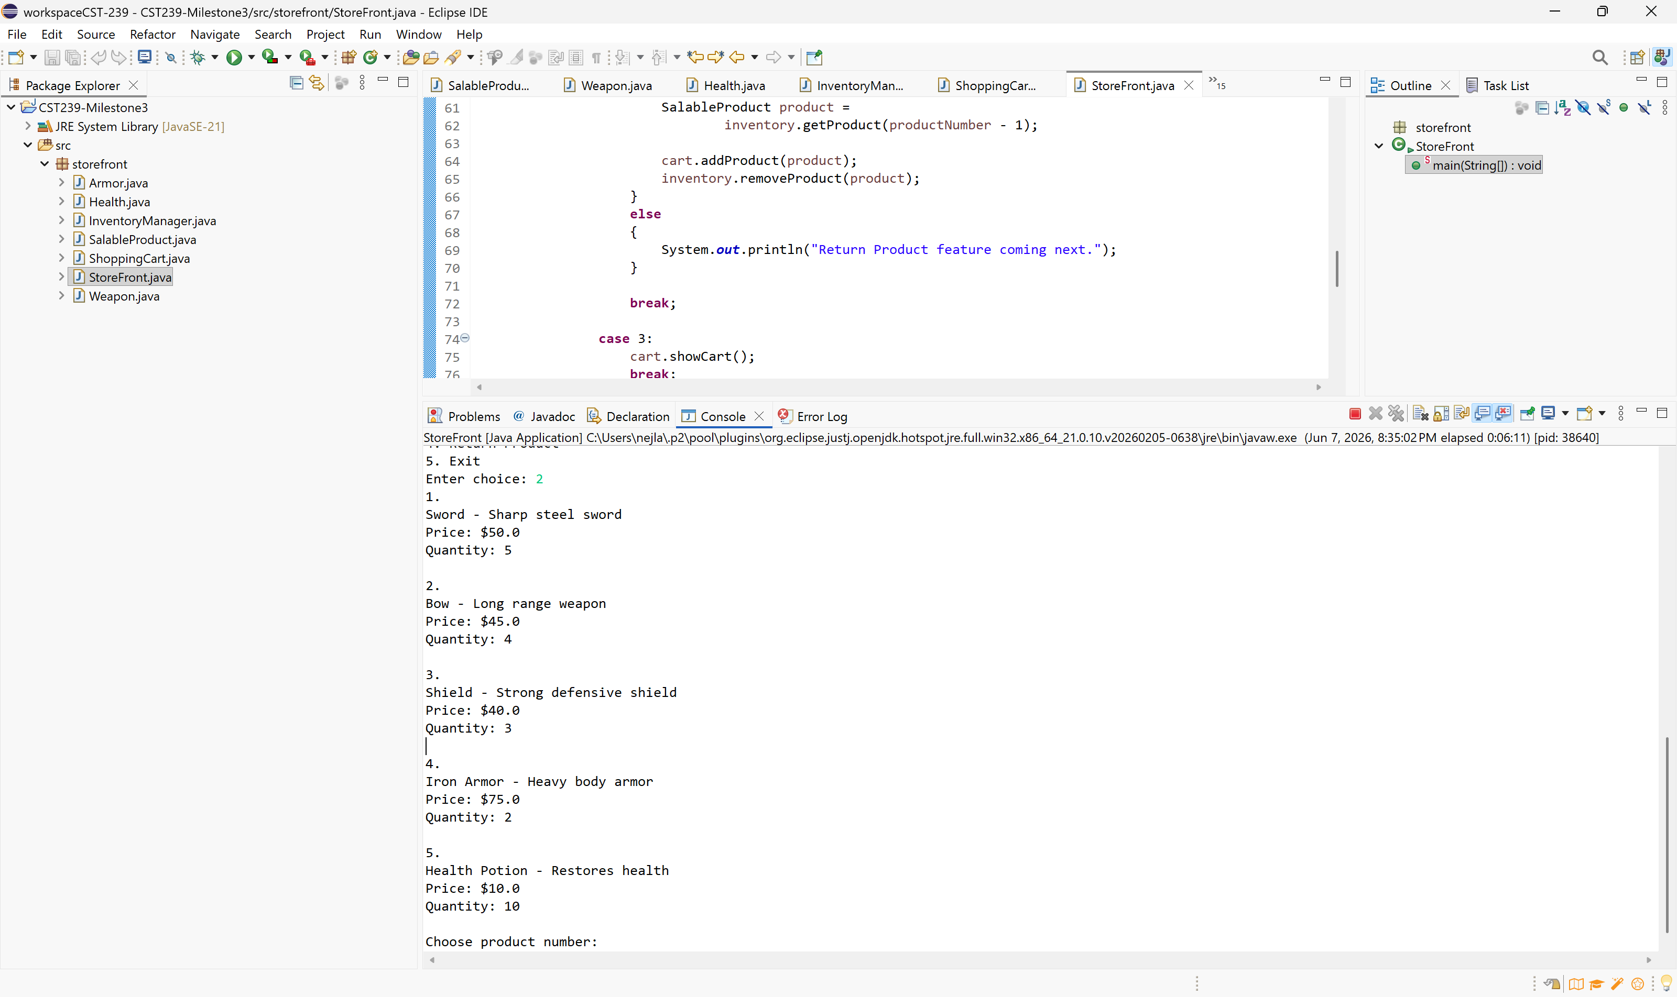
Screenshot3
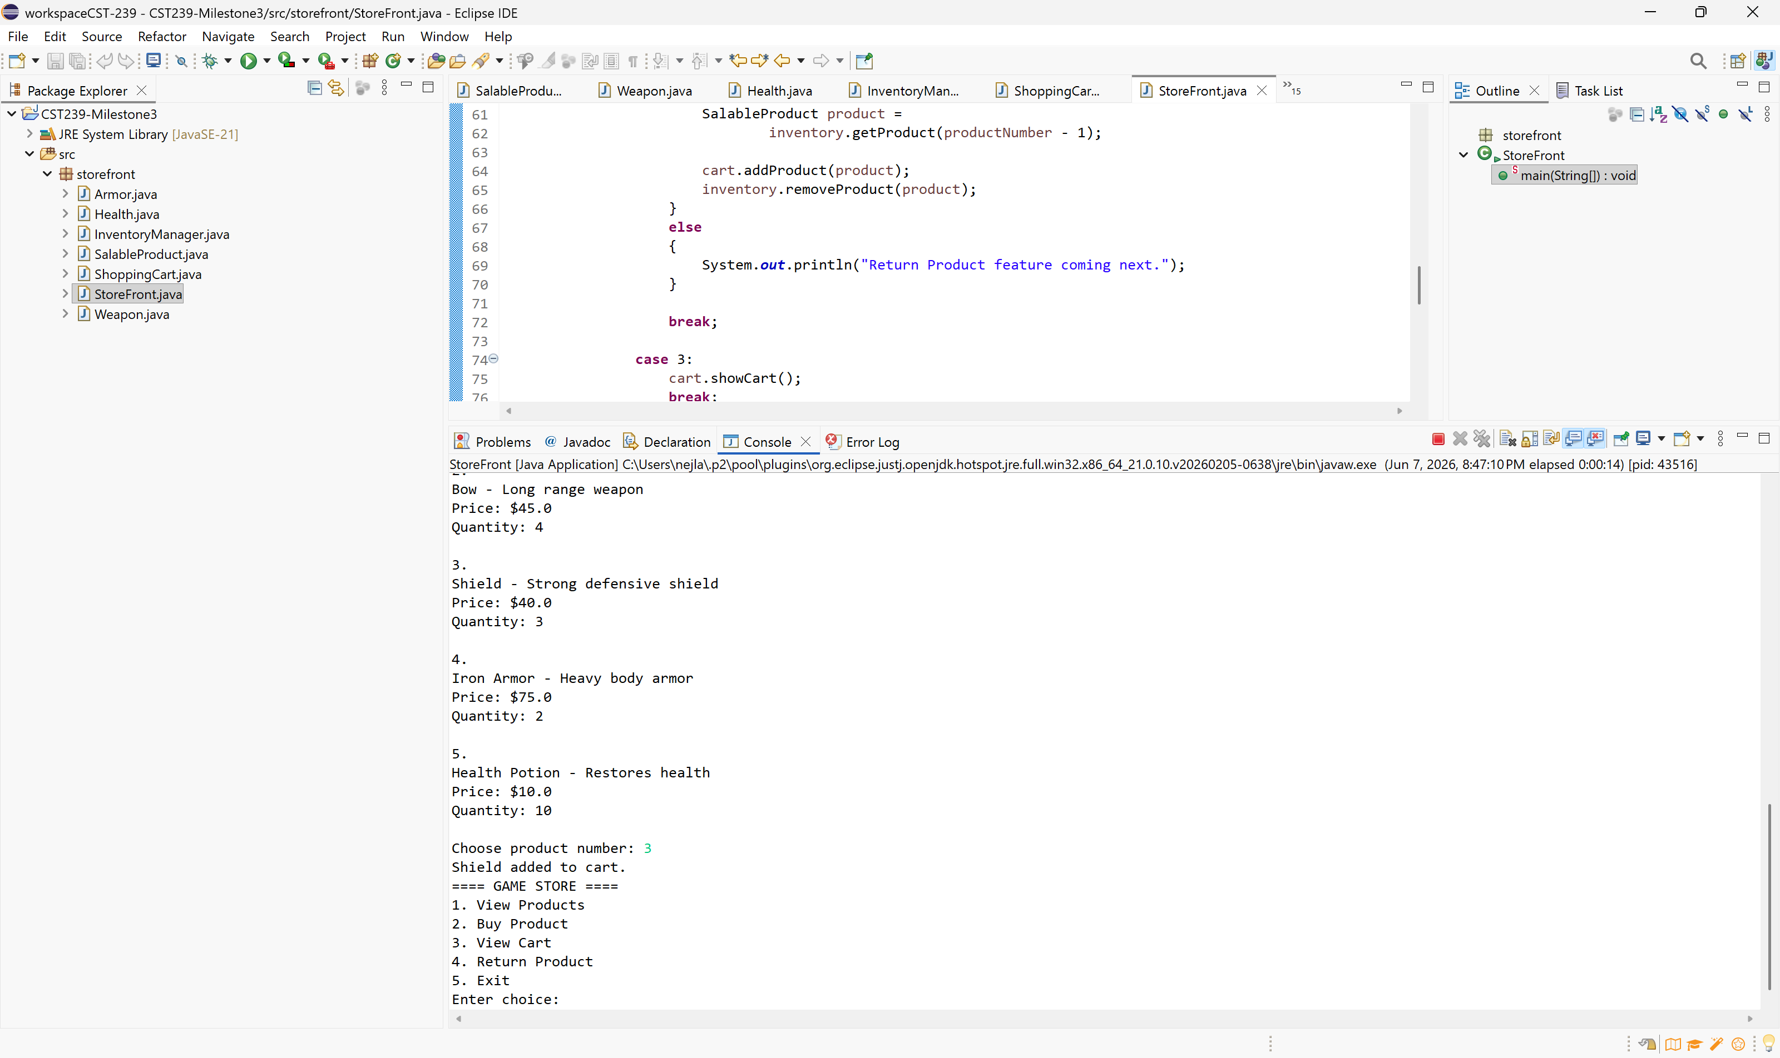

Screenshot4
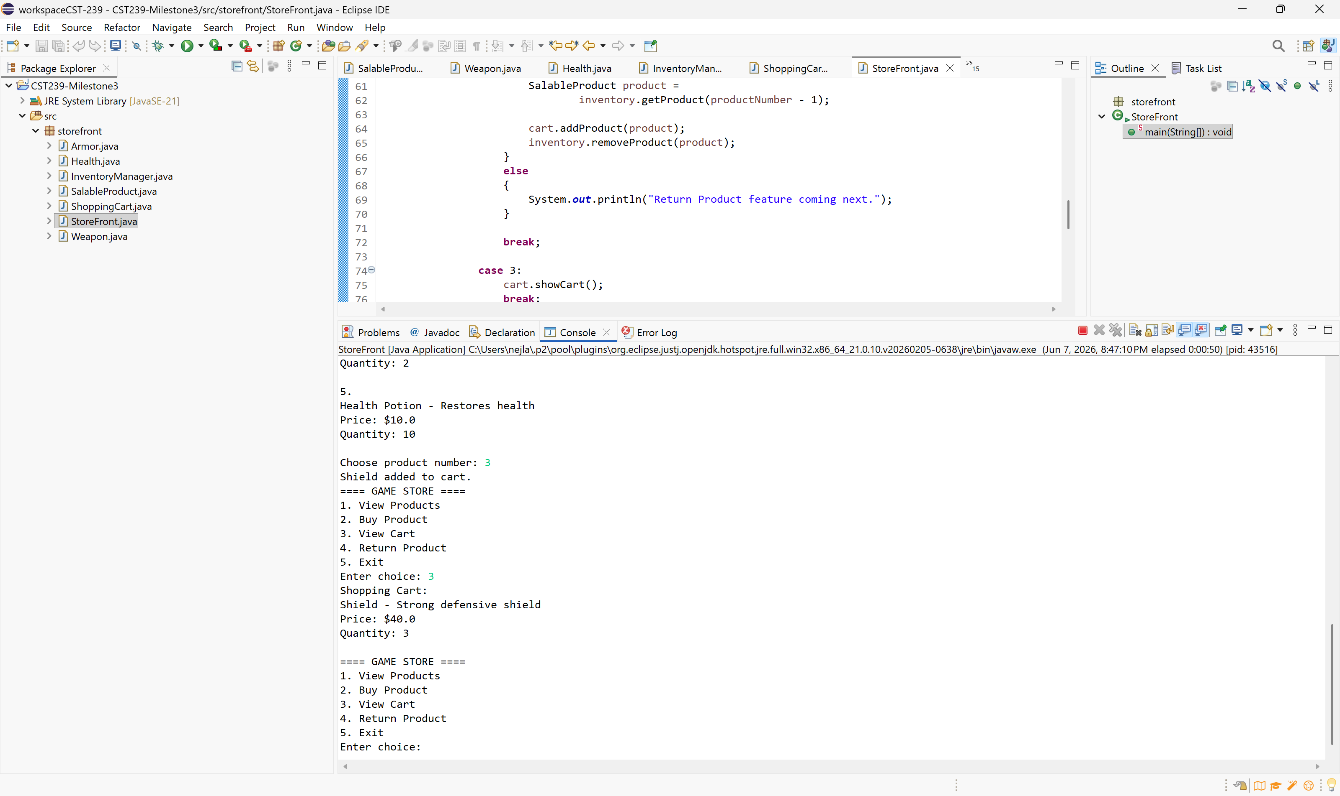
Screenshot5
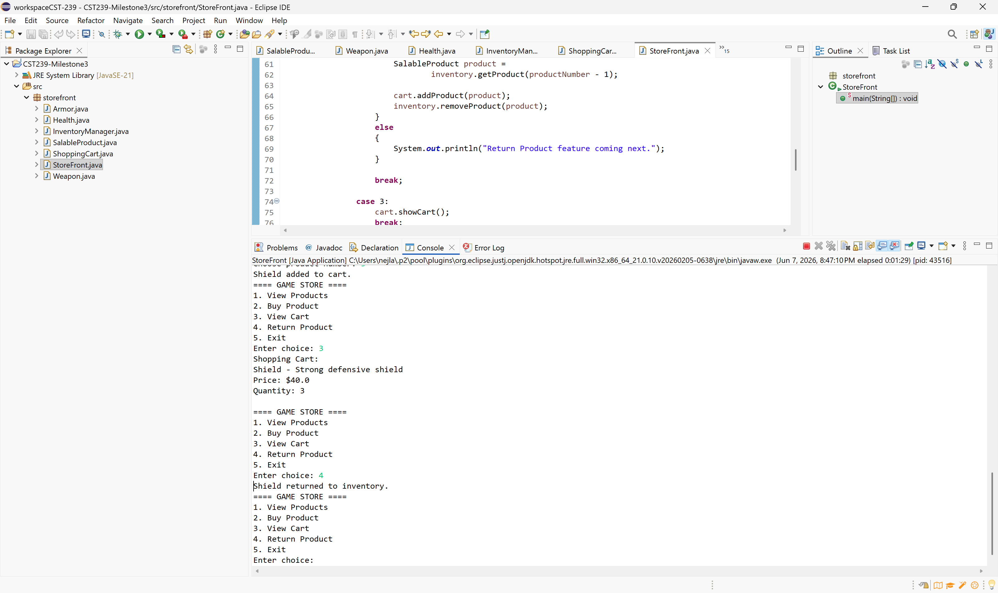

Screenshot6
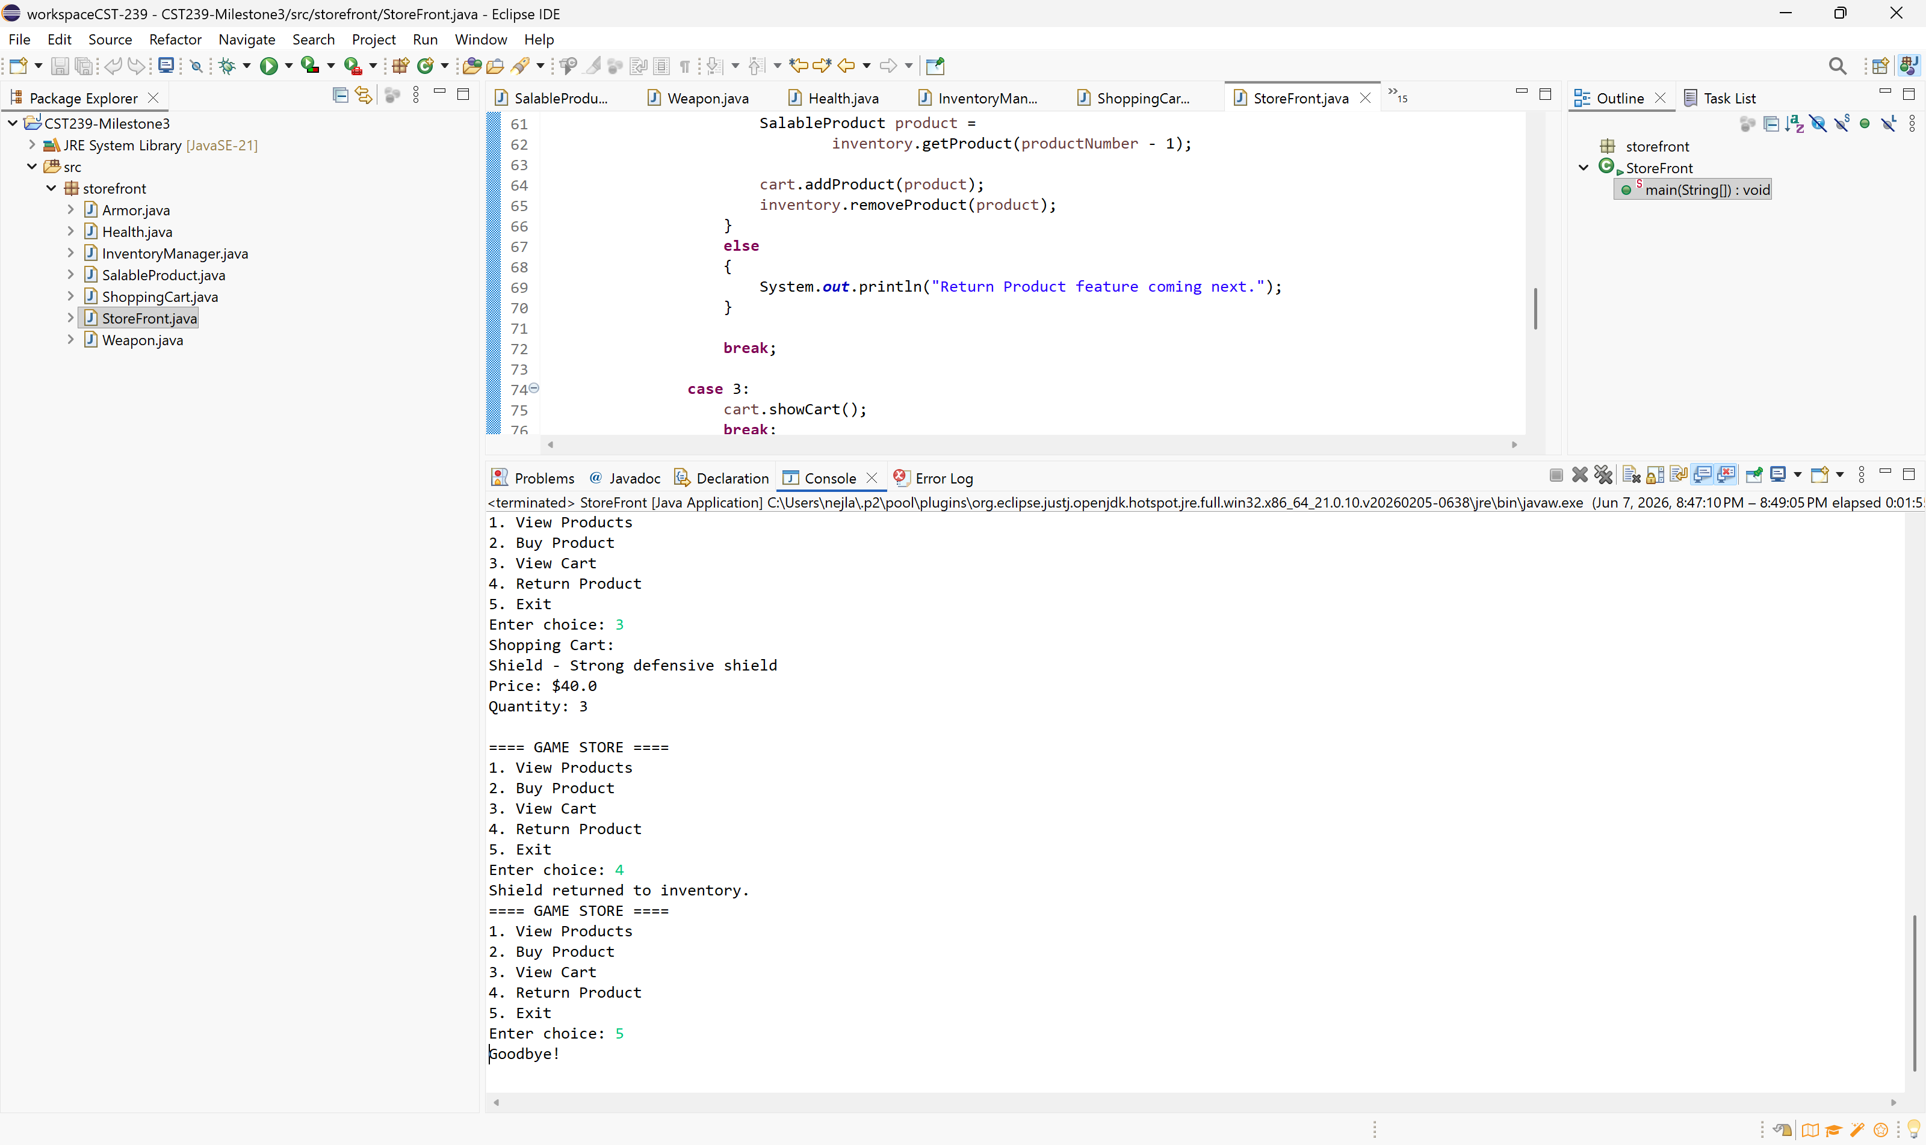
Screenshot/ JavaDoc Documentation
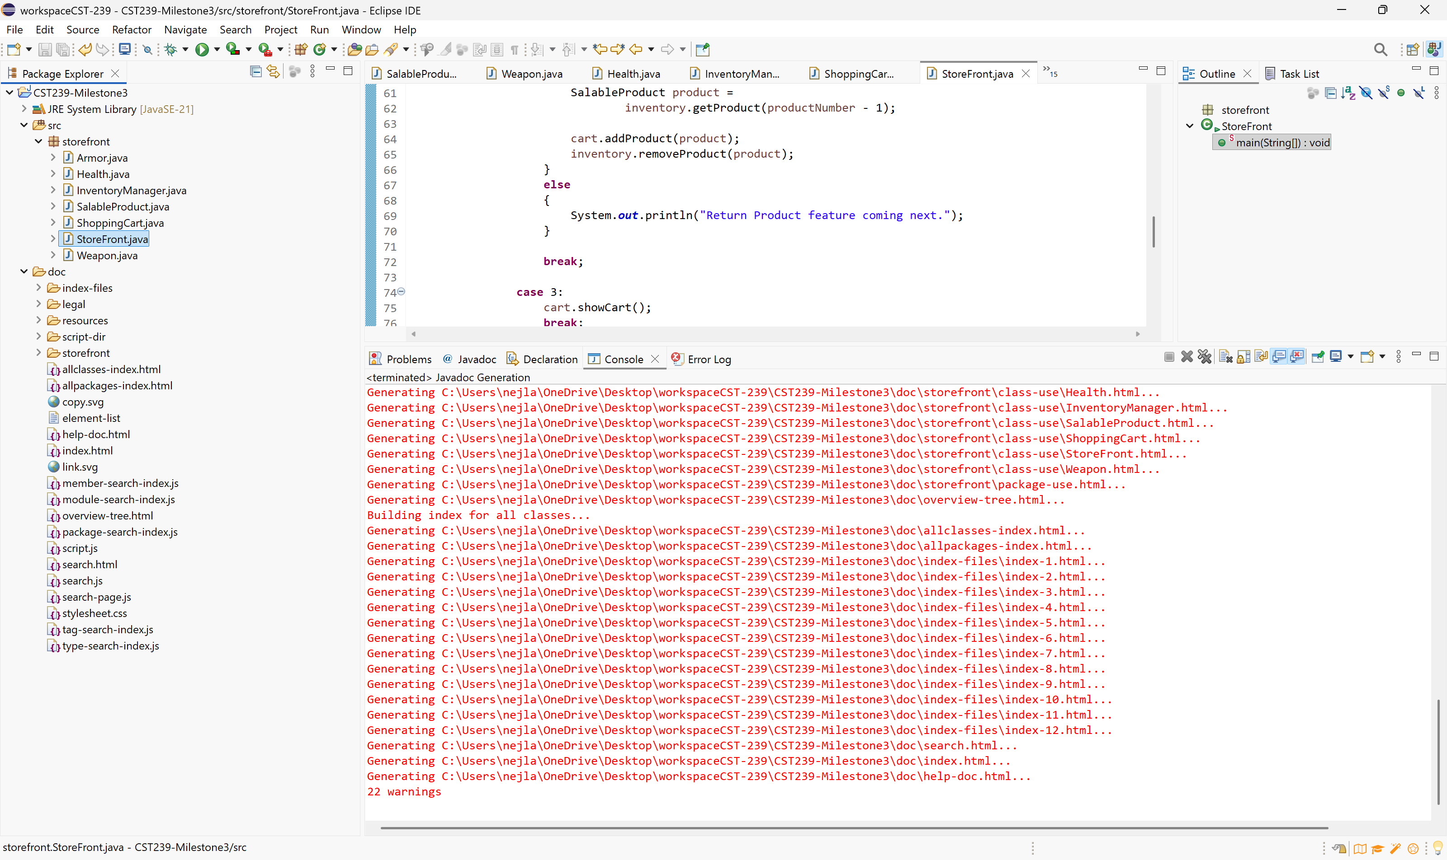
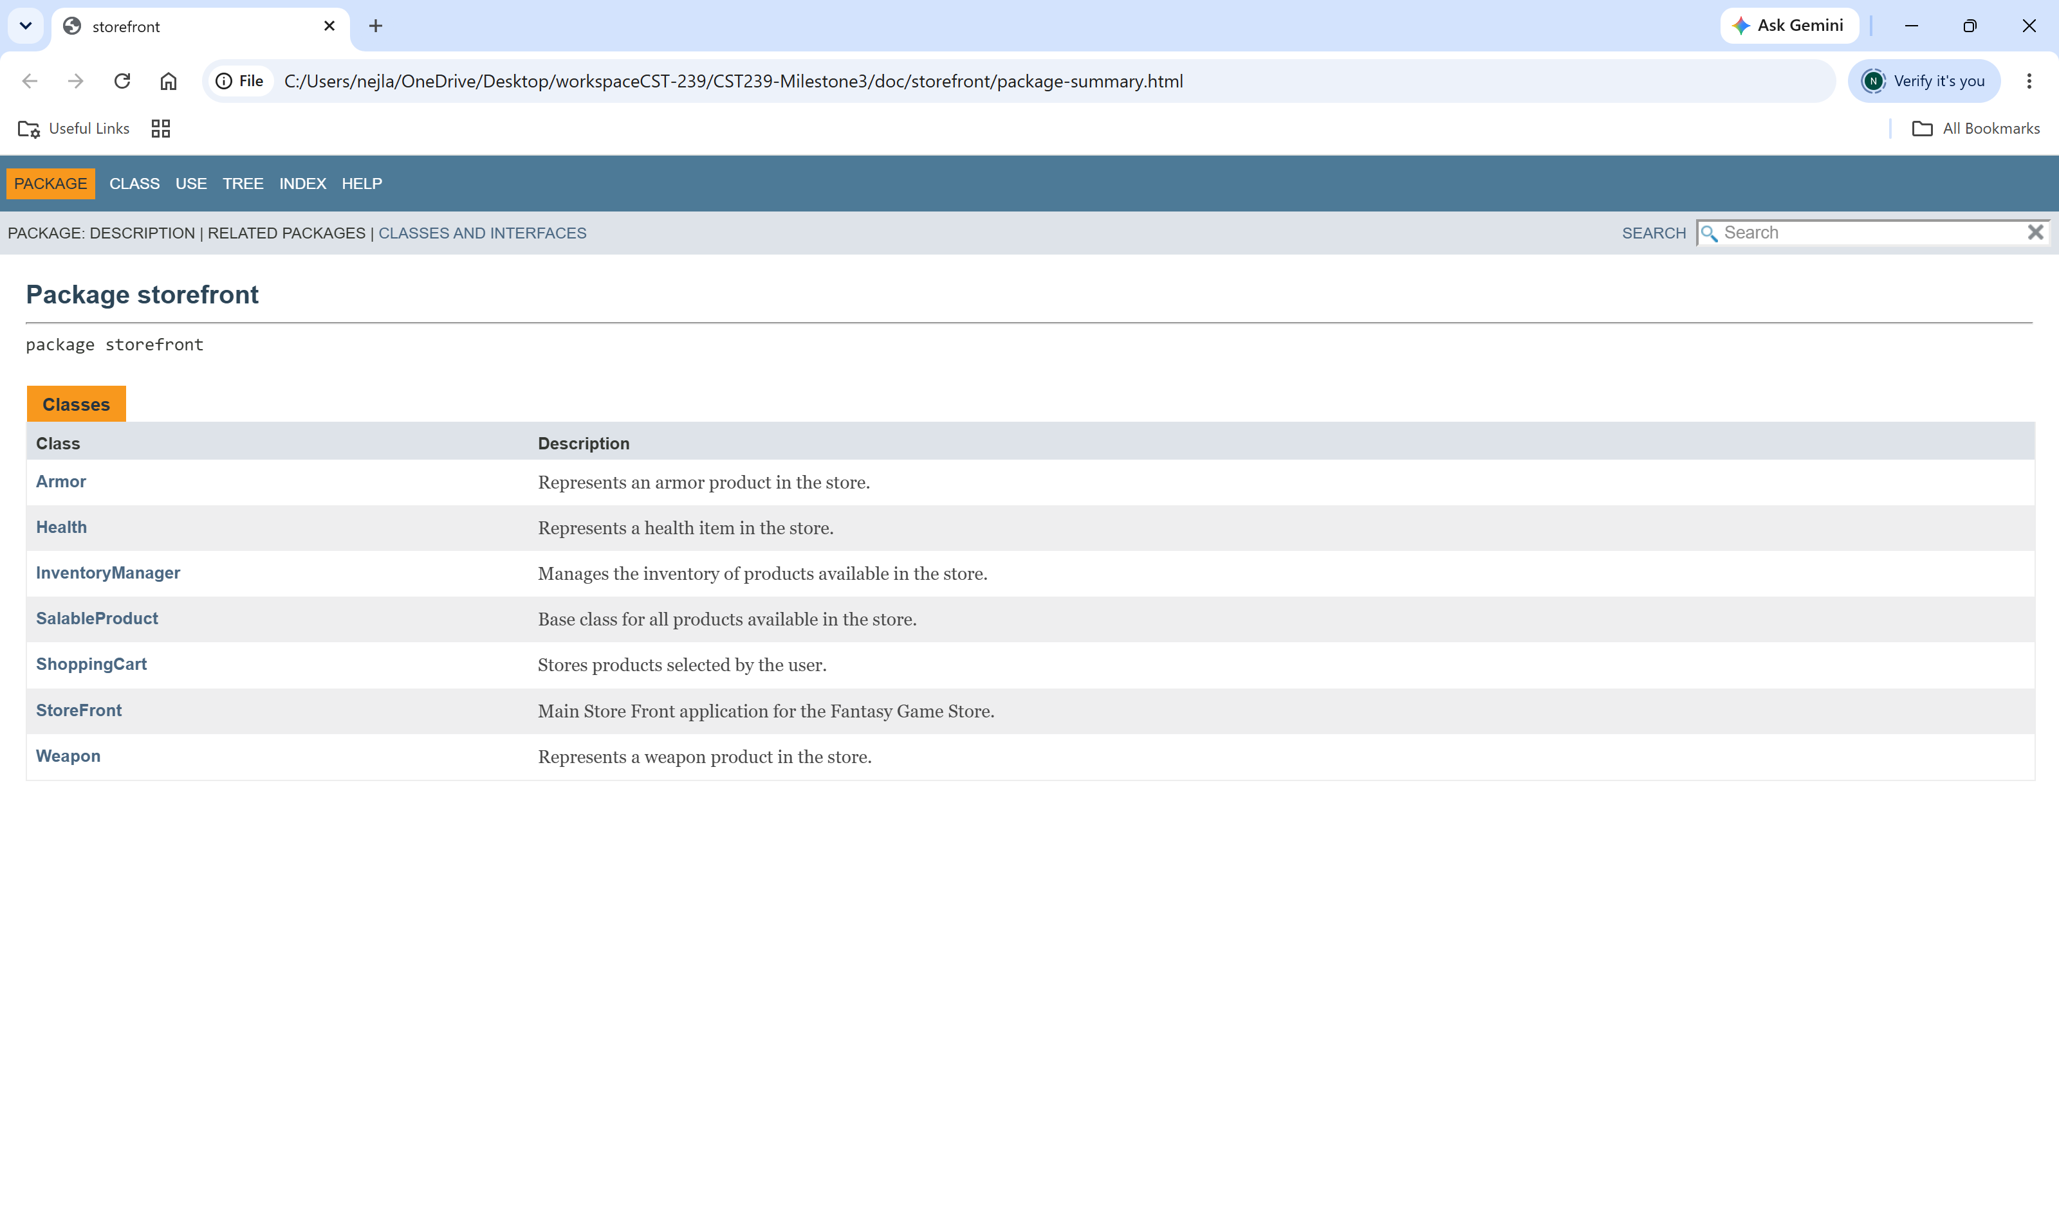

Part 1 Video:
https://www.loom.com/share/0314f20740354073aedb821b0ba30096

Part 2 Video:
https://www.loom.com/share/eff47b7753e94868b909f63446124eff

GitHub Repository:
https://github.com/nejlaybr/Milestone2
Screenshot
